CIT-227-046/2023
Desmond Mwaka
Software Engineering

File1: mergesortAssignment.py
import time
from matplotlib import pyplot as plt
import pandas as pd

#mergesort algo
def merge_sort(iter_list):
if len(iter_list) <= 1:
return

#Divide
mid = len(iter_list) // 2
left_iter = iter_list[:mid]
right_iter = iter_list[mid:]

merge_sort(left_iter)
merge_sort(right_iter)

#Merge
i = 0
j = 0
k = 0

while i < len(left_iter) and j < len(right_iter):
if left_iter[i] < right_iter[j]:
iter_list[k] = left_iter[i]
i += 1
else:
iter_list[k] = right_iter[j]
j += 1
k += 1

# Append any remaining elements from the left list
while i < len(left_iter):
iter_list[k] = left_iter[i]
i += 1
k += 1

# Append any remaining elements from the right list
while j < len(right_iter):
iter_list[k] = right_iter[j]
j += 1
k += 1

#get duration
def duration_fn(iter):
n=len(iter)

start=time.perf_counter()
merge_sort(iter)
stop=time.perf_counter()

#saving duration and n to csv file
duration=stop-start

data = {
'n': [n],
'time': [duration]
}
df = pd.DataFrame(data)
try:
df.to_csv('mergesort_duration.csv', mode='a', header=False, index=False)
print("New data successfully added")

except :
print(f"An error occurred")

#visualize csv data
def visualize():
#read stored data
df=pd.read_csv(r"mergesort_duration.csv")

x=df["n"]
y=df["time"]
#visualize
plt.plot(x,y,marker='o')
plt.title("Time Complexity of mergesort")
plt.xlabel("n")
plt.ylabel("time for exection")
plt.show()

#sample data
ff=[
[7],
[4, 1],
[3, 0,1],
[1, 9,6,3],
[2, 5,3,2,1],
[10, 9,5,7,4,9],
[6, 4,7,8,3,0,1],
[3, 9, 9,3,2,7,0,3],
[5, 6, 9, 1,3,4,1,9,6],
[4, 10, 2, 8,3,4,6,2,8,0],
[1, 7, 8, 4,3,2,1,5,7,0,9,4],
[8, 10, 2, 7,2,6,8,0,3,1,5,6,8],
[7, 4, 10, 8, 9,2,1,5,7,9,4,6,7,4],
[2, 6, 3, 0, 5, 10,3,2,1,5,6,3,9,3,0]
]

#get duration
for i in ff:
duration_fn(i)

#visualize
visualize()

File 2: mergesort_duration.csv
"n", "time"
1,1.681008143350482e-06
2,1.1791998986154795e-05
3,1.2886011973023415e-05
4,1.497400808148086e-05
5,1.2655975297093391e-05
6,2.0823004888370633e-05
7,3.670601290650666e-05
8,4.357899888418615e-05
9,4.8070010961964726e-05
10,5.6136021157726645e-05
12,7.141198148019612e-05
13,7.572802132926881e-05
14,8.307999814860523e-05
15,8.894799975678325e-05

File 3: mergesort.png

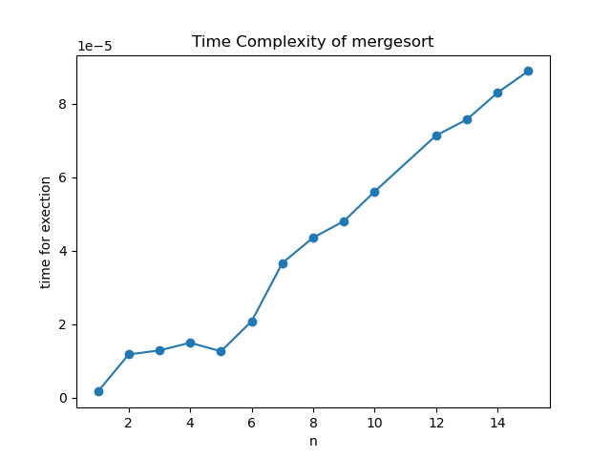

Observations
- Execution time increases as the input size increases.
- At very small values of n, the execution time appears to decelerate or fluctuate then accelerates.
Conclusions
Based on the experiment,the time taken by Mergesort increases with the size of the input list.

